

**Disclaimer: The content is curated from online/offline resources and used for educational purpose only**



**LAB MANUAL**

**Unit I – Foundation of Green Skilling, Sustainability and AI Contributions**

**Unit I – Foundation of Green Skilling, Sustainability and AI Contributions**

**Lab – 4**

**AI in Sustainable Agriculture and Food Security**

**Understanding AI's Role**

Most prominent issues regarding environmental degradation related to agrochemical use and water exploitation in conventional farming have inclined the worldwide population towards sustainable agriculture. Ecological balance and efficient food production rely on sustainable farming practices. Artificial Intelligence (AI) heads this change with its innovative solutions via complex algorithms and data analysis to provide better farm operations and decision-making.

**The Urgent Need for Sustainable Agriculture**

That is with an ever-growing global population, about 11.2 billion by 2100, and this puts so much pressure on the production of food. Traditional farming, characterized by intensive monoculture and heavy use of fertilizers and pesticides, increasingly results in soil degradation, water scarcity, and biodiversity loss. Here, therefore, sustainable agriculture has come up with a critical approach in order to diminish these hurdles whilst meeting the increasingly increasing demand for food.

**Challenges in Agriculture**

Sustainable agriculture faces several significant challenges:

* **Soil Degradation**: Intensive farming practices contribute to soil fertility loss and erosion.
* **Water Scarcity**: Agriculture is a major consumer of freshwater, exacerbating water scarcity issues.
* **Climate Change**: Disrupted rainfall patterns affect crop yields.
* **Chemical Use**: While fertilizers and pesticides can boost productivity, they also pose environmental and health risks.
* **Biodiversity Decline**: Monoculture and intensive practices reduce biodiversity, further necessitating sustainable methods.

**AI Transformations in Farming Techniques**

AI is changing the landscape of agriculture with techniques that enhance efficiency while promoting environmental conservation:

* **Precision Agriculture**: Using data from satellites and drones to optimize resource allocation.
* **Predictive Analytics**: Forecasting agricultural issues to enable preemptive action.

**Environmental and Agricultural Benefits**

AI technologies lead to reduced resource usage and lower carbon footprints. They help preserve soil health and contribute to the overall sustainability of agricultural practices.

**Key AI Innovations in Agriculture**

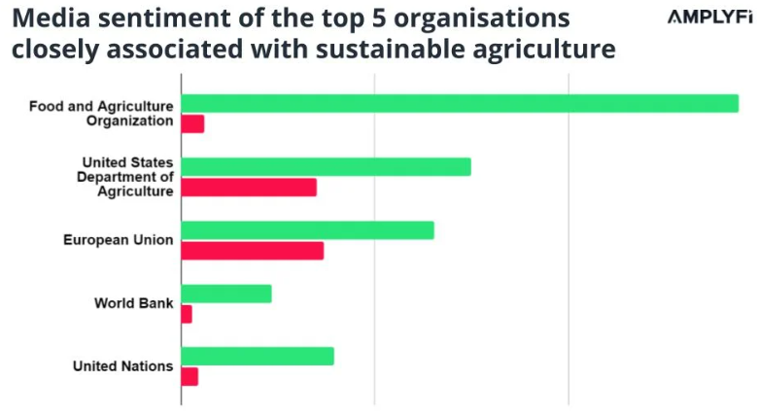

https://amplyfi.com/wp-content/uploads/2023/05/Blog-Sustainability-in-Agriculture-April-2023-2.jpg

Key technologies such as Artificial Intelligence are fast emerging trends, as shown in the bar chart above. They are leading the Agriculture 4.0 revolution with innovations – automating farming processes, reducing labour costs, minimising environmental impact, and increasing production efficiency.

**1. AI Computer Vision & Sensors**

An application of AI-powered computer vision and sensors is that it transforms farm observation capabilities related to crops and their potential problems. These technologies rely upon image recognition algorithms for the analysis of aerial and ground-level images of fields. This may help identify early signs of diseases, nutrient deficiencies, and pests, thus offering a chance for timely intervention that can reduce crop damage as well as losses minimized.

For instance, drones equipped with multispectral cameras that take pictures and post-process through AI algorithms, which detect plant health indices based on chlorophyll levels or water stress. On-ground sensors may monitor soil moisture content, temperature, and nutrient levels, providing real-time feedback to farmers and enabling them to make precise decisions on fertilization and irrigation.

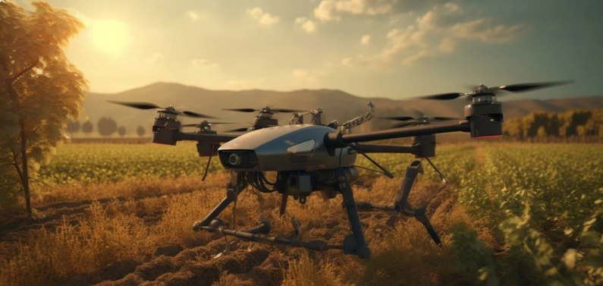

While larger-scale monitoring through AI satellite imagery determines conditions that farmers can see without physically surveying fields, this also allows for detecting patterns so that informed decisions can be made on crop management. These systems tend to reduce the need for chemical inputs of pesticides and fertilizers, leading to more sustainable farming practices.

**2. IoT Solutions for Agriculture**

This will transform agriculture further by capturing and analyzing real-time data through the connectivity of AI with IoT devices. The data from the connected devices-soil moisture sensors, weather stations, and smart irrigation systems-will be continuously transmitted concerning environmental and soil conditions. Combined with AI algorithms, this will benefit the farming process through predicting changes in the weather, crop health monitoring, and automation of systems.

For example, AI and IoT-based smart irrigation systems can autonomously control the perfect watering amount as required by the soil and weather forecasts, hence saving water wastage and giving crops the appropriate amount of moisture. The IoT also makes it easier for farmers to check their machinery and monitor their livestock from anywhere in the world.

IoT is integrated with AI to create "smart farms" that link and optimize all parts of farming elements in real time, thus reducing inefficiencies in terms of labor and resources. By using the accurate data, farmers are able to make informed decisions on planting schedules, water usage, and fertilization hence achieving more productive and less harming effects on the environment.

**3. Automated Farming Equipment**

Perhaps, in one of the areas through which robotic automation has improved agricultural operational efficiency is leverage of AI. Tractors and harvesters are highly intelligent; they do their job without much intervention with humans, moving autonomously within fields, planting seeds, and gathering crops. The machines use top-level AI algorithms and computer vision, perceiving their surroundings, observing possible obstacles, and optimizing route travel and precise operations.

For instance, computer vision-based robotic weeders can identify weeds and remove them without harming the crops. The use of chemical herbicides is thus minimized as this activity tends to be more environmentally friendly compared to other farming activities. AI-based planting machines can determine the proper depth and spacing in planting for maximum crop development.

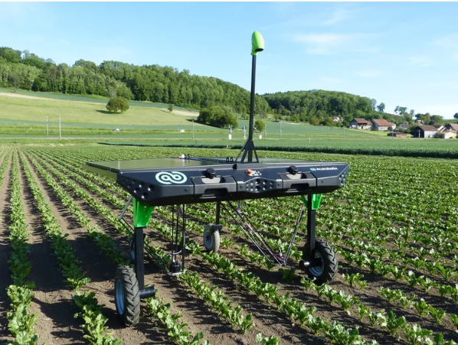

https://www.agriculture.com/thmb/TULcK-dCE6GCMgtGFl6kxRAq0lc=/750x0/filters:no_upscale():max_bytes(150000):strip_icc():format(webp)/P1230685-2000-83312f2780da478fbe7978efa6ea482e.jpg

Similarly, the role of drones in automation also encompasses spraying pesticides and fertilizers, reducing labor costs with an environmental footprint. That's why these developments allow for large-scale automation of heavily labor-intensive tasks with increased productivity and operating costs kept low while supporting sustainability.

**Future Implications**

With predictive analytics, soil health monitoring, and autonomous machinery, AI technologies in agriculture may hope to make the development in efficiency, sustainably, and resilience toward climate change. Advanced research in this industry will push the trends in precision farming practices, taking into consideration the mounting global population demand for food with reduced environmental impacts.

**Government's Role**

Government policies are essential in promoting AI adoption in sustainable farming. This includes funding research, supporting development, and regulating chemical use to facilitate the integration of AI technologies.

**Conclusion**

Integrating AI in the agricultural sector brings a significant leap towards sustainability. Big data with reasoning is made possible by AI in conducting decisions on irrigation, fertilization, and pest control; therefore, with this contribution, the effect on the environment is also reduced. Among the most significant contributions that AI has extended to precision agriculture and real-time monitoring, ensuring forward sustainable farming practices, are crucial. It's not only a technological upgrade but a need for achieving a sustainable future for agriculture.

https://amplyfi.com/2023/05/03/the-growing-impact-of-ai-on-sustainable-agriculture/